Drop the Drops

*Postmortem*

By Trinity

Gam 150 Spring 2016

Producer: Suhwan Kim

Game Designer: Jihwan Oh

Technical Director: Jooho Jung

# Postmortem

# Data Box

**Game name**: Drop the Drops

**Developer**: Team Trinity

**Team** **Members**: Suhwan Kim, Jihwan Oh, Jooho Jeong

**Length of Development**: 3 months

**Platform**: PC

# Development Team

My name is Jihwan Oh. I try to go to the army in winter vacation, but it was delayed because of my health examination and reexamine of army. So I try to find teammates in the winter vacation. Keep investigating, finally I found my teammates Suhwan and Jooho. Actually, they are the four-member team with Dohun and Jinseob, but Dohun take a rest because of his health, and Jinseob want to study more, so I joined to their team.

# Introduction

The title of our game is “Drop the Drops”. There are some kind of joke with pronunciation by word ‘Drops’, and main purpose of our game is make player’s drop to drop to sprout, so we choose that title.

The main idea of ‘Drop the Drops’ is came from water drops which arranged on the flower in my home. From that, I get some idea which I did combine drops together on the leaf or clothes and make them drop. I note that idea to my smartphone-note. I told this idea to our team mates and they agree to this feature, so use this feature to our team’s GAM150 game.

At first, ‘Drop the Drops’ is 2D side-scrolling puzzle game. But after the meeting with Professor David Ly, we change our game to ‘Grid-Based’ game. All of team members are satisfied to that idea and ensure the genre of our game, so we are really appreciate to Professor David Ly.

‘Drop the Drops’ is a 2D top-down grid based puzzle game. Water drops will spread on one leaf, and player has to move his drop which only have nutrient. Player lose water depend on movement and evaporation. There are also much kind of grids and insects which interact with player. Player needs to make strategy to clear level.

# Tools

1. **Warp Engine**

In GAM150, we used Warp Engine made by Professor Matt Casanova. Warp Engine supports the c/c++ languages, so we can use both of languages. These engine has chm file with explanation of each codes, so we can use codes which we need.

1. **Visual Studio 2013**

To use the Warp Engine, we need to use the Visual Studio 2013. This support the ‘Debug’ and ‘Release’ mode, so we can control the mode when we want to check our feature work well or check the errors.

1. **Paint, Paint.net**

Drawing tools for our game. We can control the ‘Alpha’ value with this tool. Also, there is function which called layer, so we can arrange the images with their sequence.

1. **FMOD**

There is no sound support system in the Warp Engine, so when we want to imply the sound effects to our game, we need to use a code of FMOD.

1. **Audacity**

Sound editing program for our game. When we need to cut or change volume of sounds in our game, we use Audacity.

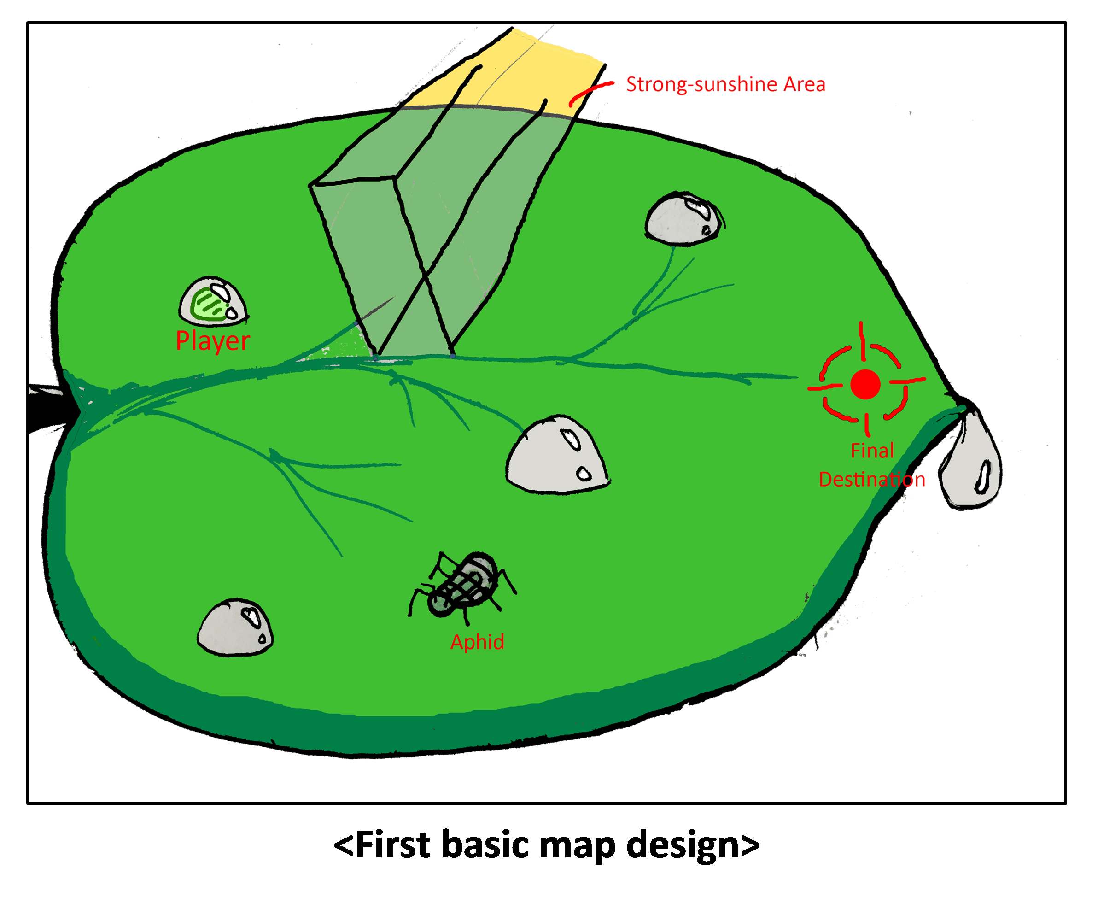

# What went wrong

## Crack of our working division.

**Jooho.jeong:**

We had our role and we know that exactly. However, the working distribution was quite a mess. Plenty of works was lean to one person in engine proof milestone. Fortunately, this was getting better as we go through the other milestones. Still, there was many confusion what I have to do or what is our next objective.

**Jiwhan.oh:**

Totally, we do not divide our work properly. Before the engine proof, the most of coding processes are worked by Jooho. After that, we divide our work. However, some works are still concentrating to one person. If someone wants to imply some feature, it is his work bodily.

## The amount of communication decrease during producing process.

**Jooho.jeong:**

I had the same problem in GAM100 and it seems that I couldn’t fix this problem. Every teammates did their own works as we planned, which is good. However, there was little conversation as time goes on. There was a few opinions on other teammates work. This brings one more problem when we combine our works. It took lots of time and efforts.

**Jiwhan.oh:**

When we divide our work, each person working on their work. So when someone absence to school when we work, if there are some problem in his part, it is hard to found and fix. Also, the works are jump over seriously when we combine our work, sometime, it was very hard to discuss about them. Even at first, when I want to find some functions, I need to keep asking where are them to Jooho.

**Suhwan.kim:**

When early this semester, we divide our work depending on each role. So someone work at home or Lab space. Sometimes we were not working together, that’s may be our problem. That happens more and more, decreasing the communication during process our games.

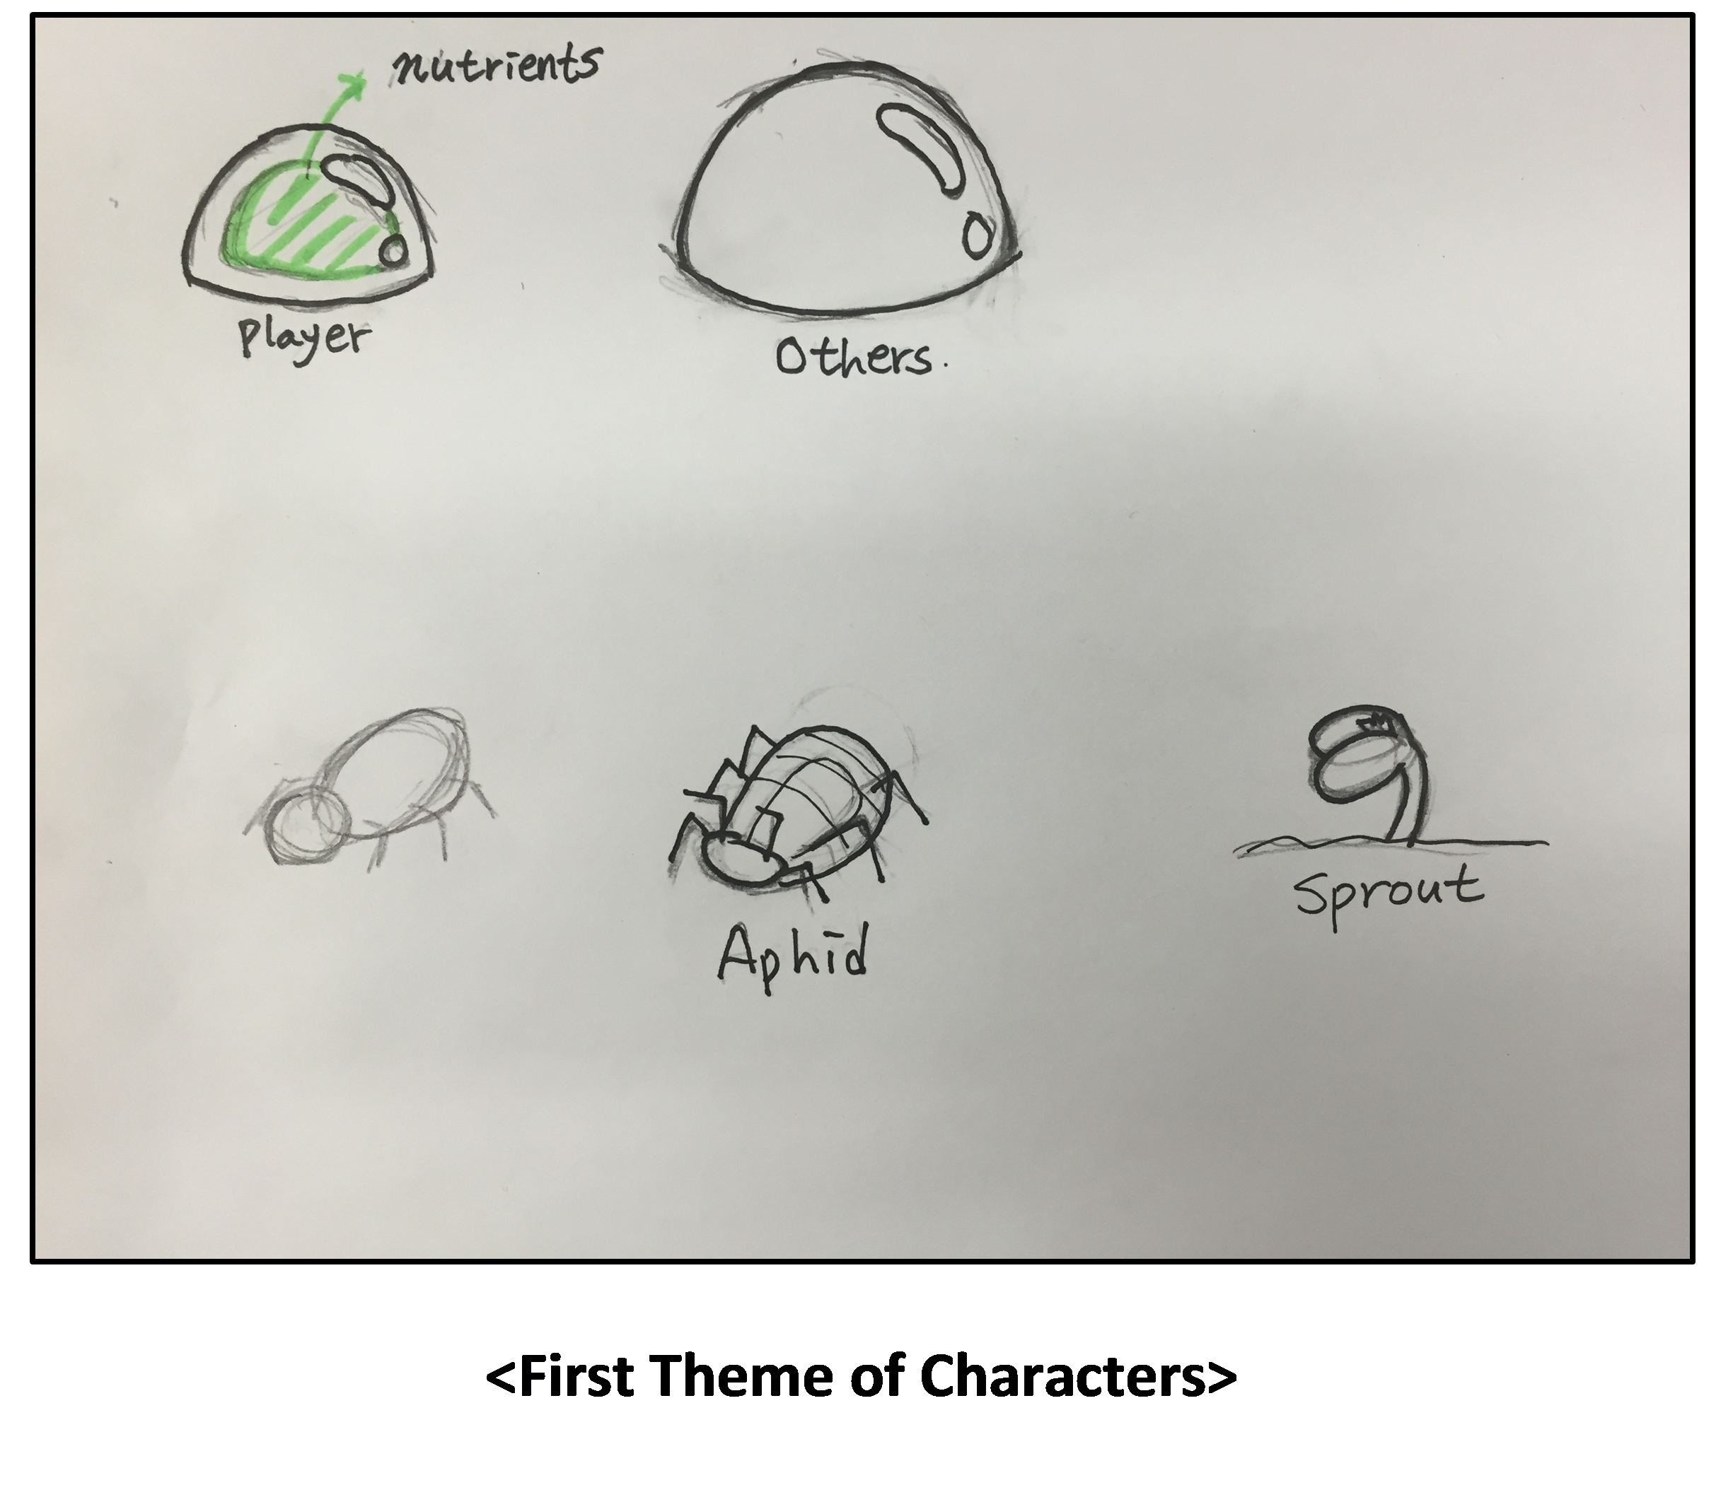

## We do not work steadily.

**Jiwhan.oh:**

This is also problem in GAM100. There are so many way to process to internet so I just digress again when working at school. Also, when I want to take a rest, it usually going to very longtime. Those things are keep accumulated, so we need to stay all night when we have a big presentation. That make me very tired. Too many crunch working.

**Jooho.jeong:**

We stayed all night before every milestone presentation. I kept asking myself, “Why am I doing this?” The plan we had was not that helpful. We put off the project when the previous milestone is done. I thought the reason was the lack of time, but it was our laziness.

**Jiwhan.oh:**

We do not word consistently, so there are so many work which we have to do at once. It was very hard to make a schedule right before the presentation. We have to stay all night, so efficient of our work was less.

**Suwhan.kim:**

We stay all night before every presentation after engine proof. We delay our work and when due date is coming, we do our work and finisi them. That's may be our laziness and communication absence.

## We didn’t think about detail things

**Jooho.jeong:**

This is also one of the problems I had in GAM100. We have a little bug related to moving triggers. This bug was found in alpha presentation. However, I concluded that this bug is very hard to find by normal players, so I didn’t fix this. I’m regretting this and I am really shameful that I made the same mistake.

**Jihwan.oh:**

I feel sad to lack of some additional animation about our insects and player’s water drop. I want to movement to player’s water drop, but we add nutrient area which change the color depending on the player’s health, so if I want to put animation, those become too complexity, so I do not add them. Also I try to move aphid’s leg and dragonfly’s wing when they move, but I do not add them.

**Suhwan.kim:**

I think we need more sound feedback for player. If the health lower than 25% (Red nutrient) add the danger sound effect, but it has some bug so I decide to delete it because due date was coming so I try to add another sound effect. Also, add to move sound effect, it will be more good but I didn’t add it. I think I miss the detail element. I have to fix it next GAM project.

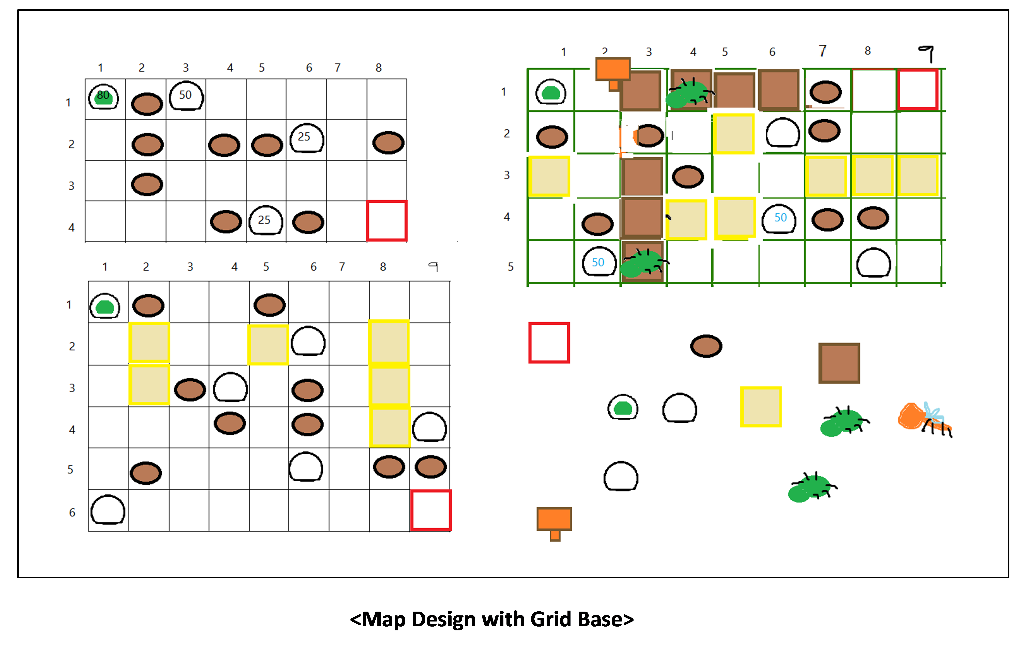

# What went good

## We almost complete our game which we planned

**Jooho.jeong:**

All the main mechanisms like absorption, evaporation and enemy AI were well implemented as we planned in the last winter vacation. Of course we had to give up special items and particle system. However the contents are enough to play, I think.

**Jiwhan.oh:**

The main feature of our game is ‘absorb’ and ‘evaporate’. We make those features right after we start the project, so they do not bother us whole semester like ‘Team Myung’. Also, we add enemies with AI. Those have not much hard AI, but they were working enough to make our game well.

**Suwhan.kim:**

The main mechanisms of drop the drops are 'absorb', 'evaporation' and enemy. That's we planned in the last vacation, also that's well realized. But particle system doesn't add it, because drop the drops already visual quality is good, also particle system isn't matching to drop the drops, in my opinion.

## It was very nice we stay up all night when we need to hard working.

**Jiwhan.oh:**

When we have a presentation, we leave in our lab and working together. So with this work, we can discuss and change our game immediately.

## Coding systems composed well, so it was easy to combine and composing.

**Jooho.jeong:**

Now that I think of my GAM100 game, the whole game system was not well-organized. It was like a pile of dirty codes. Rough organizing was automatically done by Zero Engine, but my team, my plan, my head wasn’t. Working Drop the Drops, I had to organize the whole game by myself. It was quite hard to do that, but I feel very good about that because ‘I’ did it.

**Jiwhan.oh:**

Different from the GAM 100, the codes are well divided by jooho. After the alpha, jooho makes the filters in our project and arrange our codes with their role by make them to function. So after that, it was much easy to find the codes and modified them.

**Suwhan.kim:**

We use the different engine before GAM 100, also we learend about C++, so we easliy understand the composition of code, also teammate joo ho do well organized the base code of drop the drops.

## There are many features came from the playtesting.

**Jooho.jeong:**

Moving triggers, in-game UI, and many other components were changed thanks to play testing. This reminds me that play testing is the most important thing in game producing.

**Jiwhan.oh:**

With the playtest, we decide many features. I delete the HUDs which show the health of player and clear condition. Actually, HUDs are kind of my personal greed, but after the playtest, I decide to delete them because those feature’s never help player. Also, there are many features from the comments in survey. I think playtesters are also game developers, so when I apply those ideas to our game, our game got even better and better.

## We make our game which I planned before the semester, so it was easy to producing our game after semester.

**Jooho.jeong:**

We had a couple of online meeting, and discussed our game concept. The ‘Drop the Drops’ was also named in the meeting. It was good to have that because my GAM100 game concept was made within 20 minutes and I feel regret about that. It was right to taking this early meeting for granted but I didn’t know that in one year ago.

**Jiwhan.oh:**

The main feature of ‘Drop the Drops’ is already created in the pre-digipen. I choose different game at GAM100, but with our meeting in winter vacation, our team chooses this feature. Because we choose our main theme early, it was very easy to modify and apply many features to our game.